# **Challenge #2**

# **Brief**

In this project, we're creating an eCommerce component.

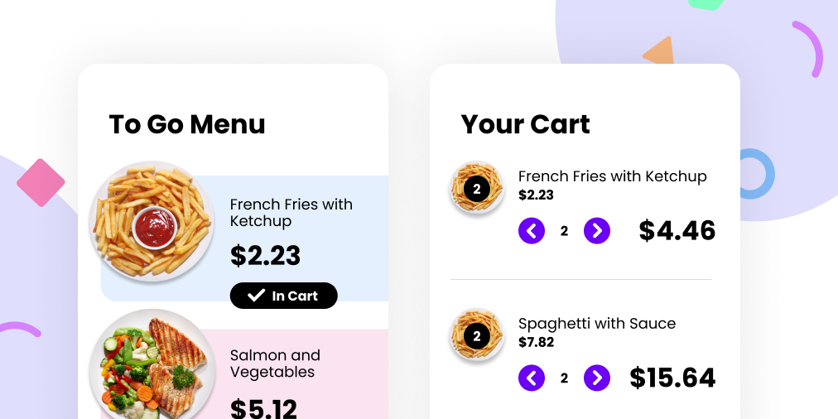

You can use as many (or as few) tools, libraries, and frameworks as you'd like. If you're trying to learn something new, this would be a great way to push yourself.

# 

# **Users should be able to:**

* View the plates on the left side of the screen and add them to your cart on the right side.
* When there are no plates within your cart, you should see a message that says, "Your cart is empty."
* When a plate is added to your cart, the Subtotal and Totals will automatically update.
* When products are in your cart, you should be able to increase and decrease the quantity.
  + A user should not be able to mark the quantity as a negative number.
  + If the quantity goes down to 0, the user will have the option to delete or remove the product from their cart entirely.
* Tax is based on the state of Tennessee sales tax: 0.0975

Need some support on this challenge? Join the [Learn Build Teach](http://learnbuildteach.com/) Discord community. We have a separate channel set up specifically for the Advent of JavaScript.

# **Getting Started**

1. To get started, download the zipped files (within Podia). This includes all the project assets you need to get started: HTML, CSS, and images.
2. Take a look around. Look at the project's Figma file. This is a great way to see how the pieces and parts should look within the browser.
3. Open the project's README.md file. It has additional information on how the project is structured.
4. Customize your project/file architecture to your liking.
5. Happy coding!
6. Once you're finished, share your work using #adventofjs

# **Taking your Project to the Next Level**

* Use a framework like [React](https://reactjs.org/), [Vue](https://vuejs.org/), or [Svelte](https://svelte.dev/). Or, if you're feeling particularly adventurous, try writing everything in Vanilla JavaScript.
* Try adding animations and transitions when an item is added, updated, or removed from your cart.
* Take a step back and try writing the HTML and CSS for this project yourself. Start with the provided Figma file. If you get stuck, you can always purchase the [Advent of CSS](http://adventofcss.com/) solutions, where Amy explains how to build this.

# **FAQs**

* Can I use libraries/frameworks on these projects?
  + Of course! We're providing the vanilla HTML and CSS, but you can use whatever tools and frameworks you'd like.
* Oh no! I'm stuck!
  + Check out the [Learn Build Teach Discord.](http://learnbuildteach.com/) We have a specific channel set up, just for the Advent of JavaScript.
* Can I use this project in my portfolio?
  + Sure! But, be honest about the work that *you* did